**Assignment #1 – Virtualization Concepts**

Tasks:

* Explain the different types of virtualization.

Purpose:

* Clarify: Distinguish between Type I, Type II hypervisors, and Containers.
* Summarize: Be able to explain each type of virtualization.

Assignment:

* Virtualization: Virtualization is the process of creating virtual instances of physical resources, such as servers, storage devices, and network resources. It allows multiple virtual machines (VMs) to run on a single physical machine.
  + Type I Hypervisors: Also known as bare-metal hypervisors, these run directly on the physical hardware, providing better performance and efficiency. Examples include VMware ESXi and Microsoft Hyper-V.
  + Type II Hypervisors: These run on a host operating system, which then runs the VMs. They are typically used for development and testing. Examples include VMware Workstation and Oracle VirtualBox.
  + Containers: Unlike hypervisors, containers virtualize at the OS level, sharing the host OS kernel among containers, which makes them lightweight and fast. Examples include Docker and Kubernetes.

**Assignment #2 – Virtualization Concepts**

Tasks:

* Explain the different types of virtualization features.

Purpose:

* Clarify: Distinguish between Resource Allocation, Isolation, Snapshotting, Live Migration, and Cloning.
* Summarize: Be able to explain each type of virtualization feature.

Assignment:

* Resource Allocation: Virtualization allows dynamic allocation of resources (CPU, memory, storage) to VMs based on their needs, optimizing resource usage.
* Isolation: Each VM operates independently, ensuring that issues in one VM do not affect others, enhancing security and stability.
* Snapshotting: This feature captures the state of a VM at a specific point in time, allowing users to revert to that state if needed.
* Live Migration: This enables moving a running VM from one physical host to another with minimal downtime, aiding in maintenance and load balancing.
* Cloning: Creating an exact copy of a VM, useful for scaling and testing without affecting the original VM.

**Assignment #3 – Virtualization Concepts – Golden Image**

Tasks:

* Explain what a Golden Image is, and how it’s used.

Purpose:

* Summarize: Be able to explain what a Golden Image is.

Assignment:

* Golden Image: A Golden Image is a pre-configured template of a virtual machine or system that includes the operating system, software applications, and configurations. It is used to quickly deploy multiple identical systems, ensuring consistency and saving time on setup.

**Assignment #4 – Virtualization Concepts – ISO File**

Tasks:

* Explain what an ISO File is, and how it’s used.

Purpose:

* Summarize: Be able to explain what an ISO File is.

Assignment:

* ISO File: An ISO file is a disk image of an optical disc, containing the complete data of a CD, DVD, or Blu-ray, including the file system. It is used to distribute large software packages, install operating systems, and create bootable media for software installation.

**Assignment #5 – Live Class Exercise – Deploy Ubuntu 22.04 Linux Server (NO GUI)**

Tasks:

* Deploy an Ubuntu 22.04 Linux Server in VirtualBox.

Purpose:

* Apply: Using the in-class guidance, install and deploy a Linux Server.
* Construct: Build a Virtual Machine.

Assignment:

* Screenshots:
  + Instructions followed.
  + Each step of the installation process.
  + Linux Server native commands and outputs.
* Text Box:
  + Encryption: Protects data by converting it into a coded format that is unreadable without a key.
  + Steps and Accomplishments:
    1. Downloaded Ubuntu ISO file.
    2. Created a new VM in VirtualBox.
    3. Configured VM settings (memory, storage).
    4. Mounted the ISO file and started the VM.
    5. Followed the installation prompts to set up Ubuntu Server.
    6. Configured network settings and created user accounts.
    7. Completed installation and performed initial updates.

**Assignment #6 – Live Class Exercise – Discovery**

Tasks:

* Demonstrate switching Virtual Network Modes in VirtualBox.

Purpose:

* Clarify: Discover the difference between NAT and Bridged Modes.
* Apply: Be able to modify Network Modes in VirtualBox.

Assignment:

* Screenshots:
  + Instructions followed.
  + Each step of the process.
  + Changes in Linux, especially the IP addresses.
* Text Box:
  + Network Modes:

NAT (Network Address Translation): Provides a private IP address to the VM, sharing the host's IP address to access the internet. Useful for general internet access.

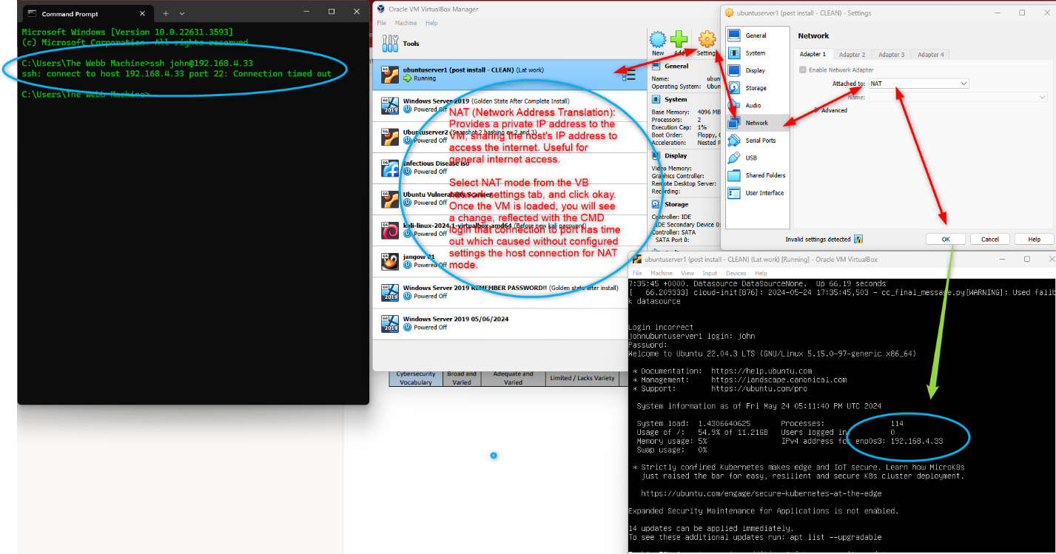

Select NAT mode from the VB network settings tab, and click okay. Once the VM is loaded, you will see a change, reflected with the CMD login that connection to port 22 has timed out which can be caused without configured settings from the host for a NAT mode connection.

Bridged Mode: Connects the VM directly to the physical network, giving it its own IP address. Suitable for VMs that need full network access and visibility.

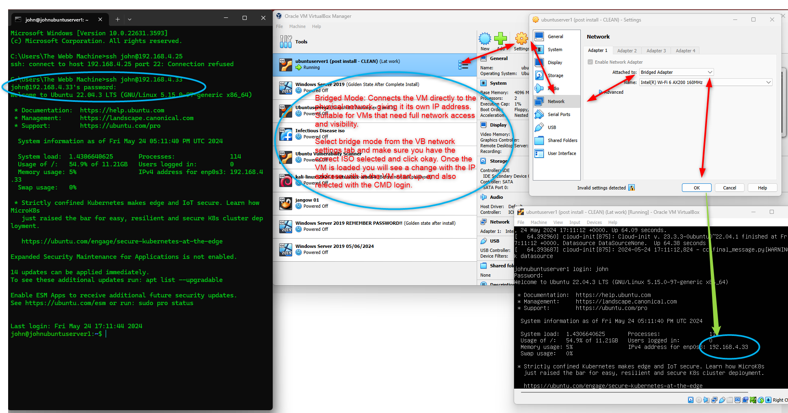

Experience:

* Switching between NAT and Bridged modes in VirtualBox involved configuring network settings in the VM settings menu.
* Observed changes in IP addresses and network connectivity, confirming the VM's network mode was correctly modified.